AZURE STORAGE

Resource Group

* A logical container

Storage Account Creation in AZURE

* Premium Account
  + Page Blobs
  + File Shares
  + Block Blobs
* Locally Redundant Storage (LRS)
  + Within the same data center there are multiple copies of the data
* Zone Redundant Storage (ZRS)
  + There are multiple zones within a data center separated by a certain distance.
  + Each zone has a copy of the data.
* Geo Redundant Storage (GRS)
  + Within a region pair where the regions are separated by a distance of 300 Km, there are copies of the data.
  + Data duplication happens synchronously 3 times in a date center by default.

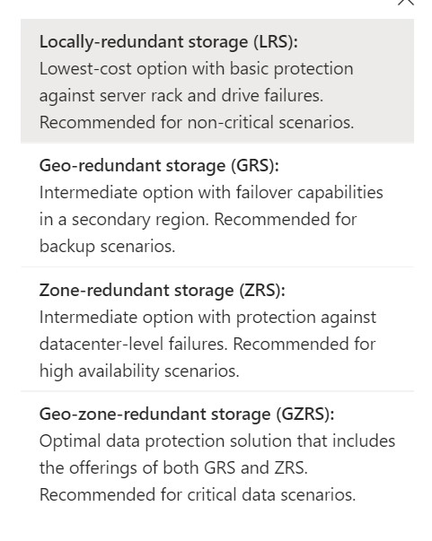

* Read Access Geo Redundant Storage
  + Users get access to the Secondary storage directly instead of the primary storage.
  + The benefit of this is that the read operation can happen simultaneously.
  + Replication is different from write operation.
  + In case of critical failure in the primary storage, the delay in the switchover from primary to secondary storage can take some time which might result in loss of data.
  + RAGRS prevents this and provides seamless servicing.
* SLA
  + Service Level Agreement
    - The type of service the cloud service providers agree to provide.
* Depending on the amount paid, different levels of services are provided.
* GA: General Availability
* Endpoint: the link that connects to a resource
* Upstream & Downstream
  + Upstream is where the data comes from
  + Downstream is where the data will be sent after due transformation.
* SFTP is not available for BLOB.
  + It is only available for hierarchical namespace.
* Subscriber is called tenant.
  + Communication between tenants is called cross-tenant communication.
  + Replication of data from one tenant to another is called cross-tenant replication.
  + Tenant ID is used for cross-tenant replication.
* Access Tier
  + Hot: frequently accessed data (frequently)
  + Cool: infrequently accessed data and backup scenarios (min 30 days)
  + Cold: infrequently accessed data for longer period than cool (min 90 days)
  + Archive: long-term storage of data (min 180 days)
  + In hot more is paid for storage so less is incurred on accessing the data
  + In cold less is paid for storage so more is incurred on accessing the data
  + Purging of data(deleting)/Archiving happens to release storage.
* Soft delete
  + If something is delete using soft delete, the files can be retrieved within the next 7 days.
* BLOB change feed
  + The number of days for which the data is maintained. Before that threshold the data is deleted
* Azure CosmosDB is used for all kinds of data storage.

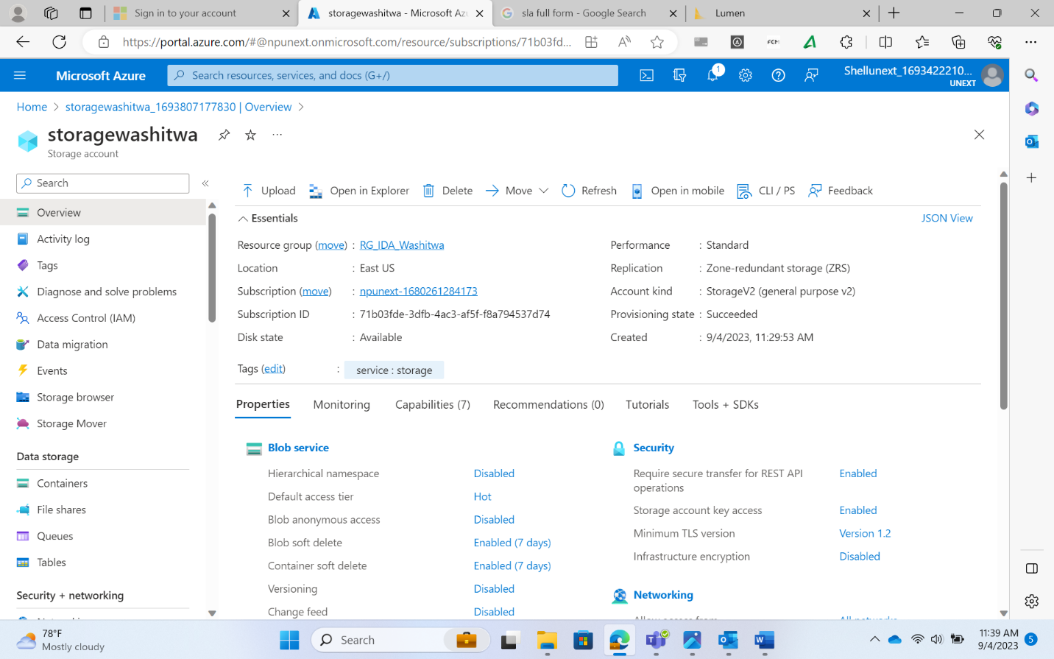

* In Big Data processing, the data is present in multiple subfolders.
  + To allow the creation of subfolders, ADLS Gen2 need to be used
  + Azure Data Lake Storage Gen2(ADLS Gen2)
  + To create a Gen2, go to storage account, create, Advanced tab, enable hierarchical namespace.
  + The above will cause the creation of Gen2 storage.
  + Sub folders are not available in BLOB storage that is why ADLS Gen2 is used
* A container can also be created to store this ADLS Gen2 instance.
* Access permissions in ADLS Gen2
  + Read
  + Write
  + Execute

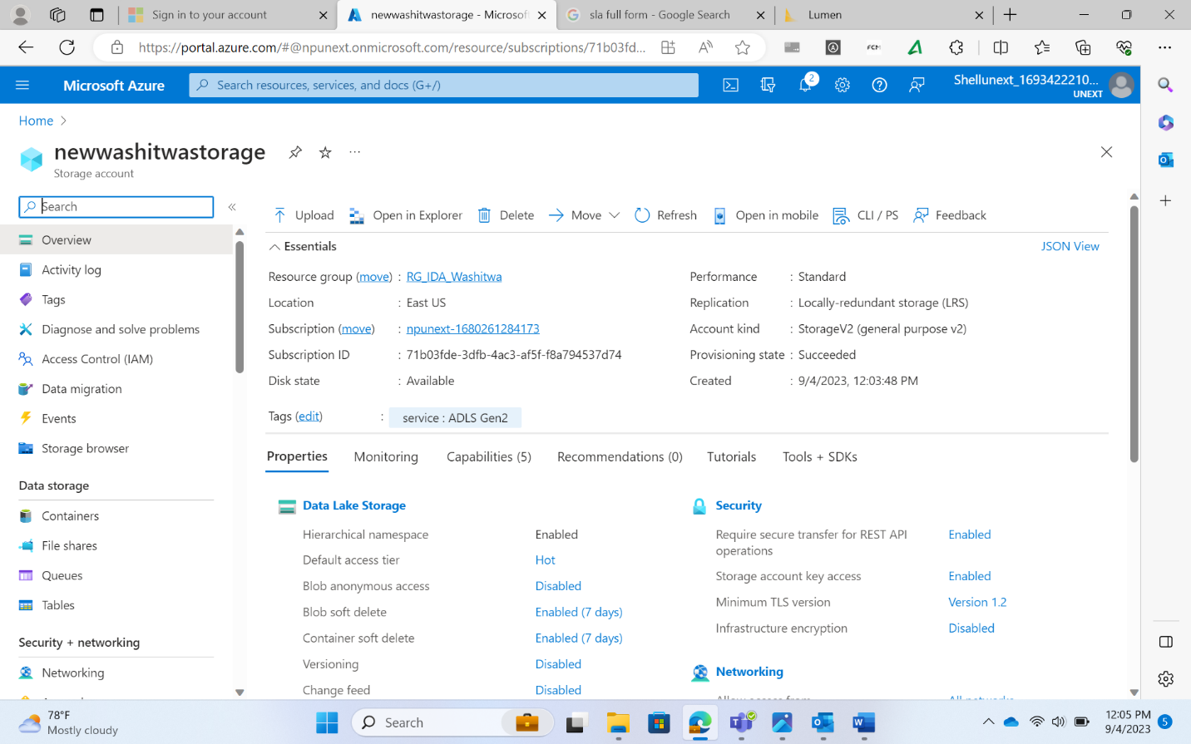

Creation of BLOB, Files, Tables, and Queues

To report any issues:

* [support@nuvepro.freshdesk.com](mailto:support@nuvepro.freshdesk.com)

For file share:

* Create an Azure Data Lake Storage Gen2
* Create a file share
* Click on connect
* Copy the script generated
* Upload a demo file in the file share
* Create a VM with windows 2019 image
* Connect to the VM using Remote Desktop Connection
* There run the script in windows PowerShell
* The file share is reflected in the VM, containing the demo file inside

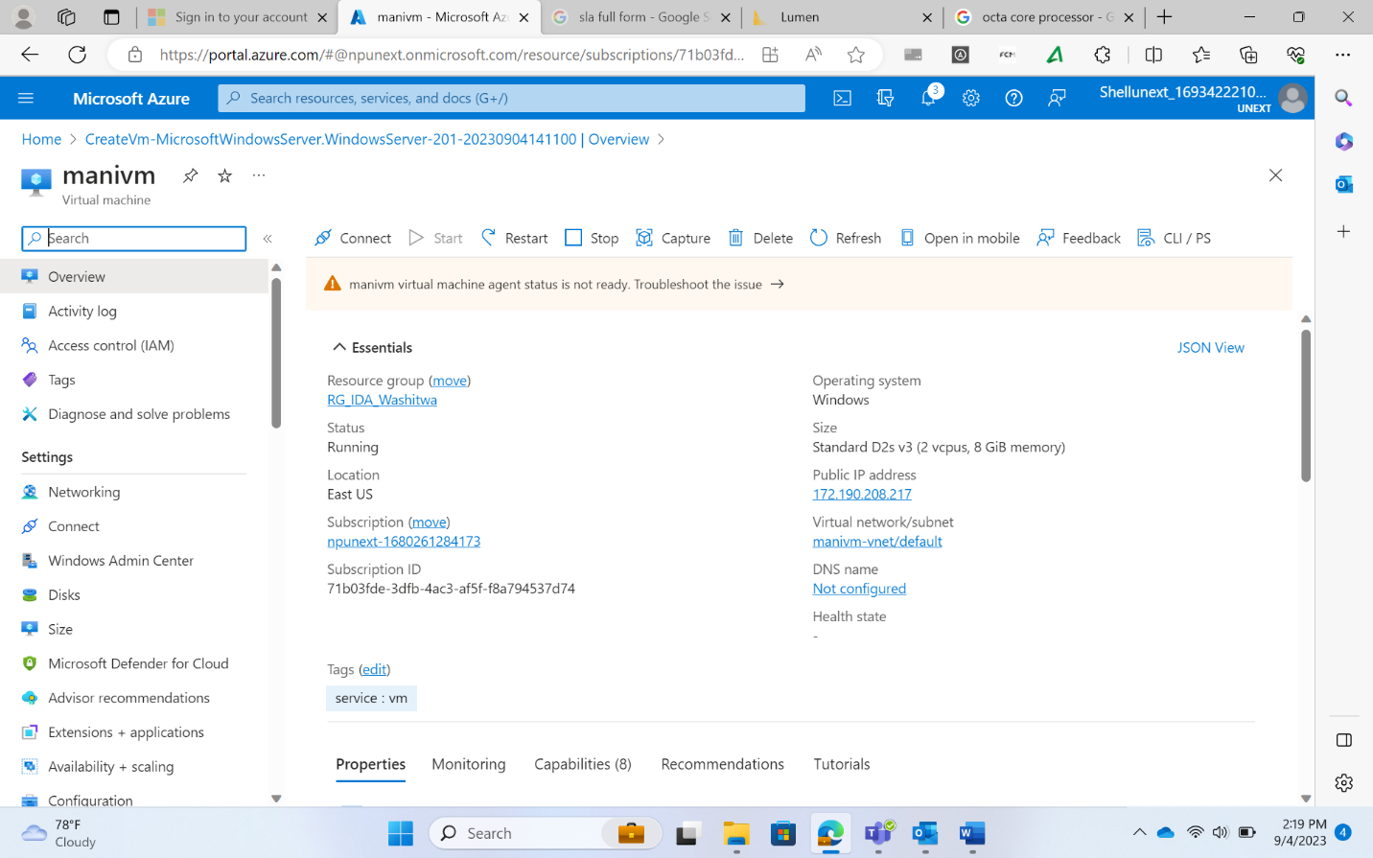

New File Share

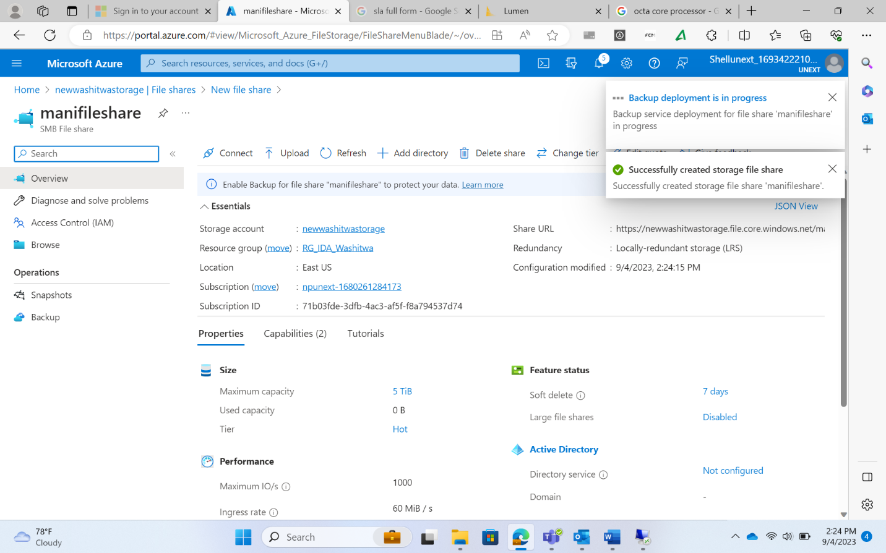

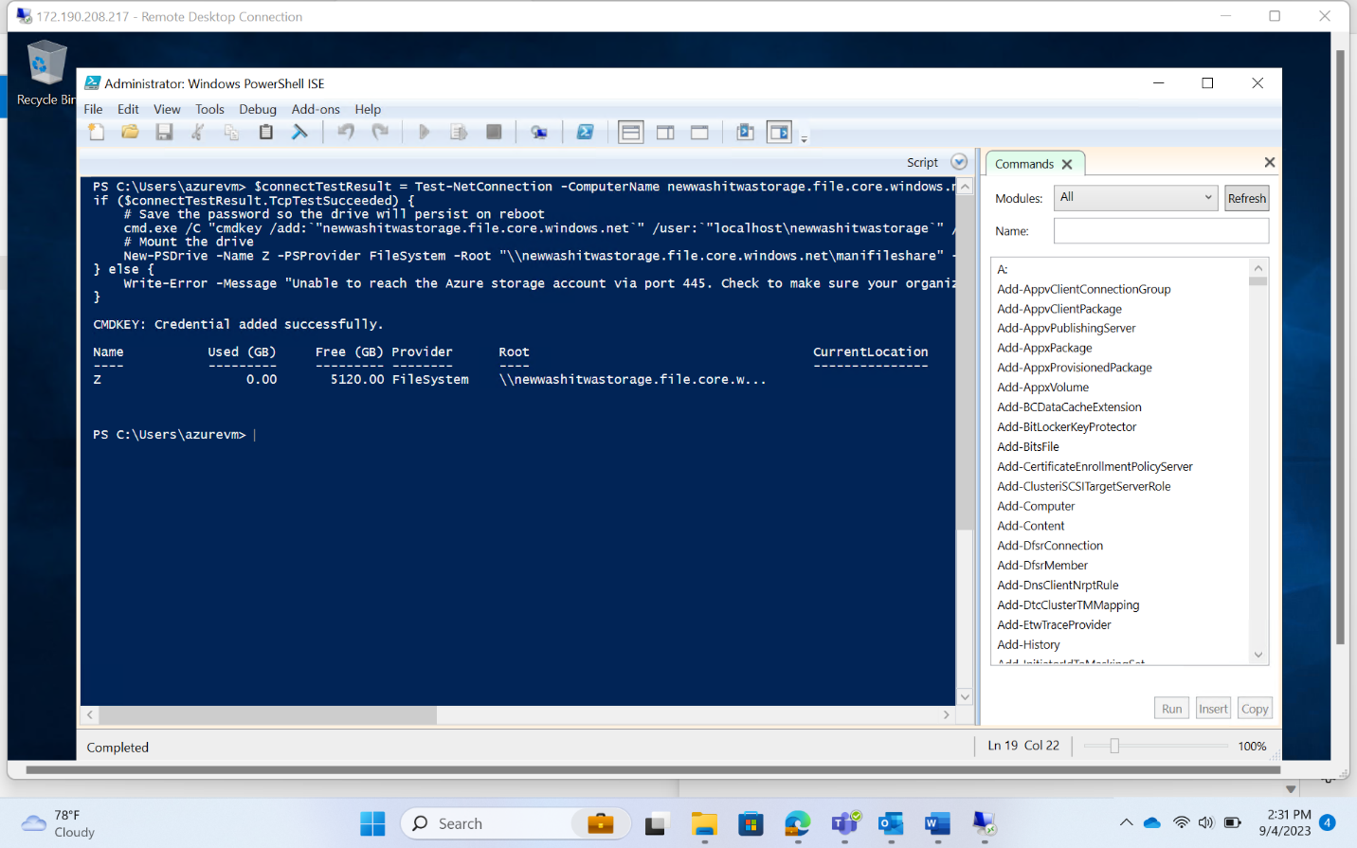

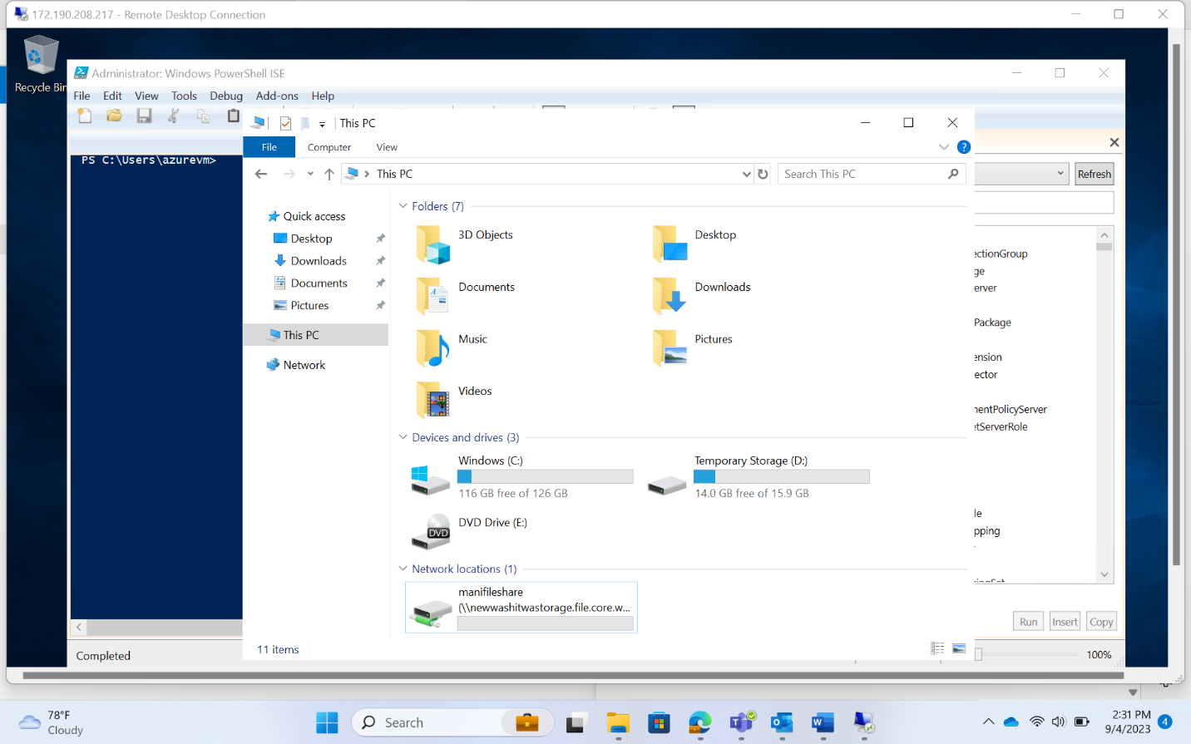

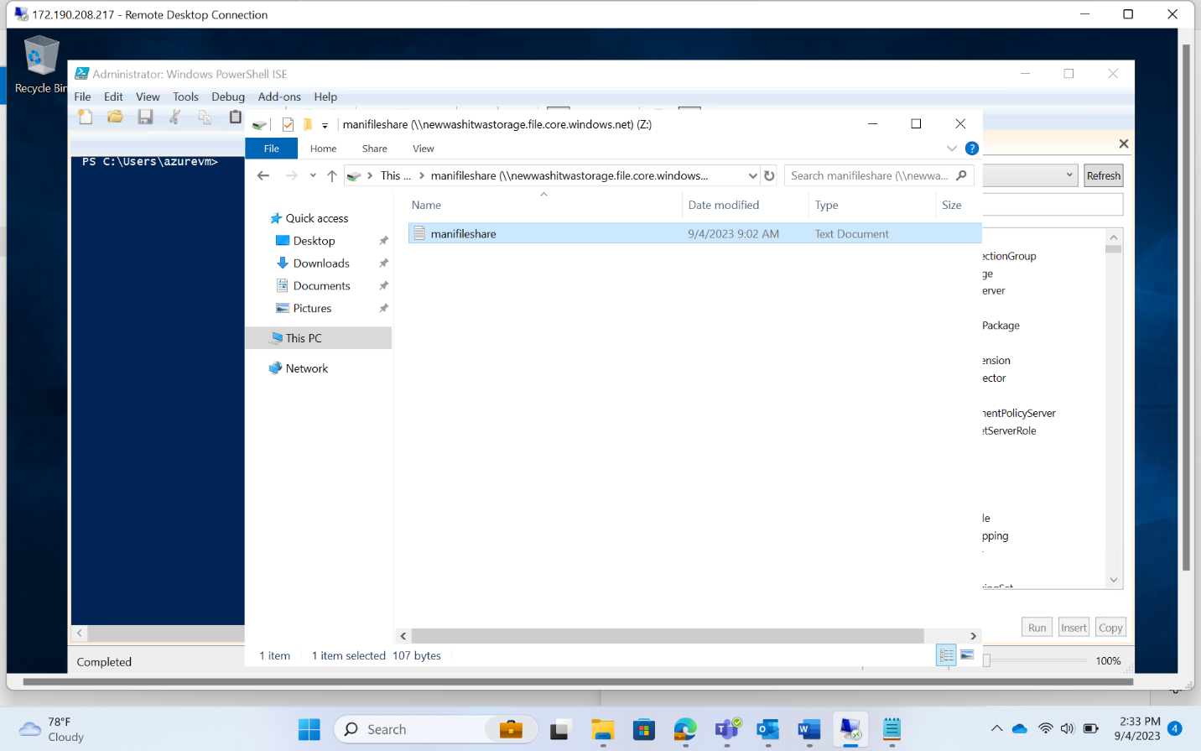

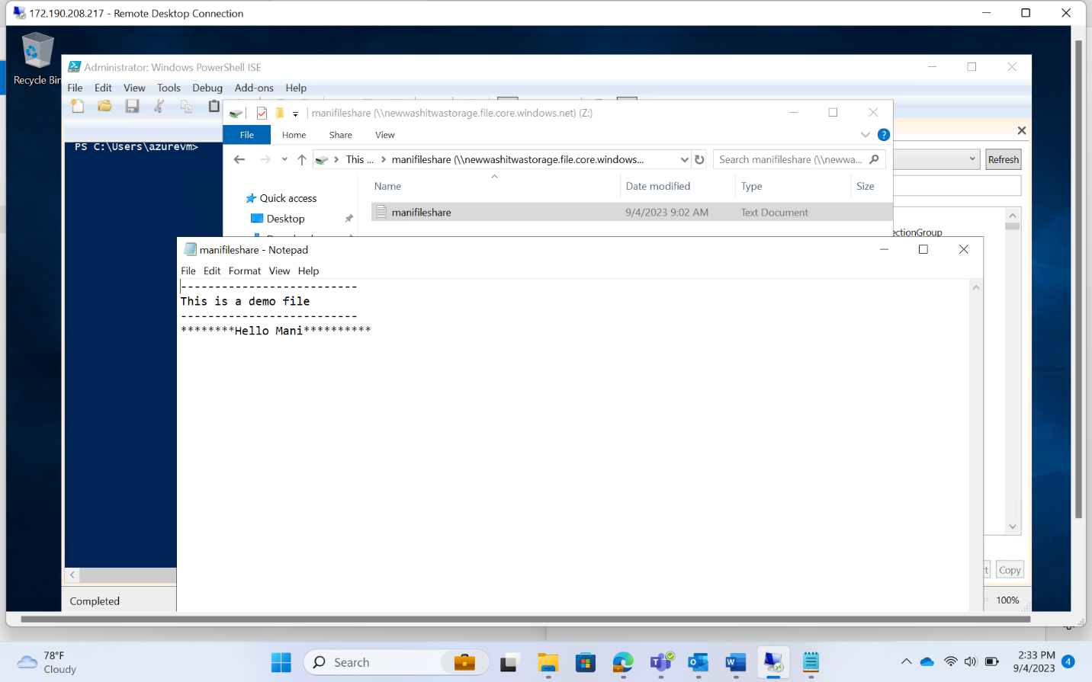

Snapshots

* Snapshots keep a record of the file status
* To compare the changes that happen in a file, snapshots can be used
* To restore a file to a previous version, click on that particular snapshot and click restore

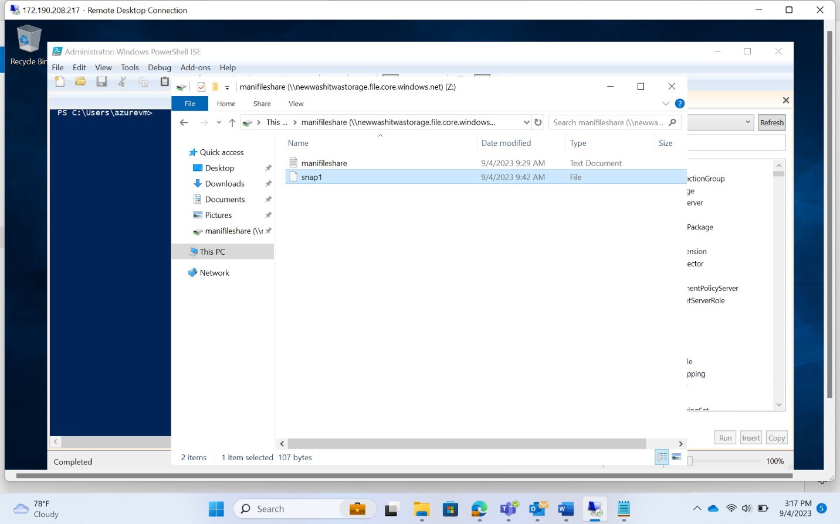

Table Creation

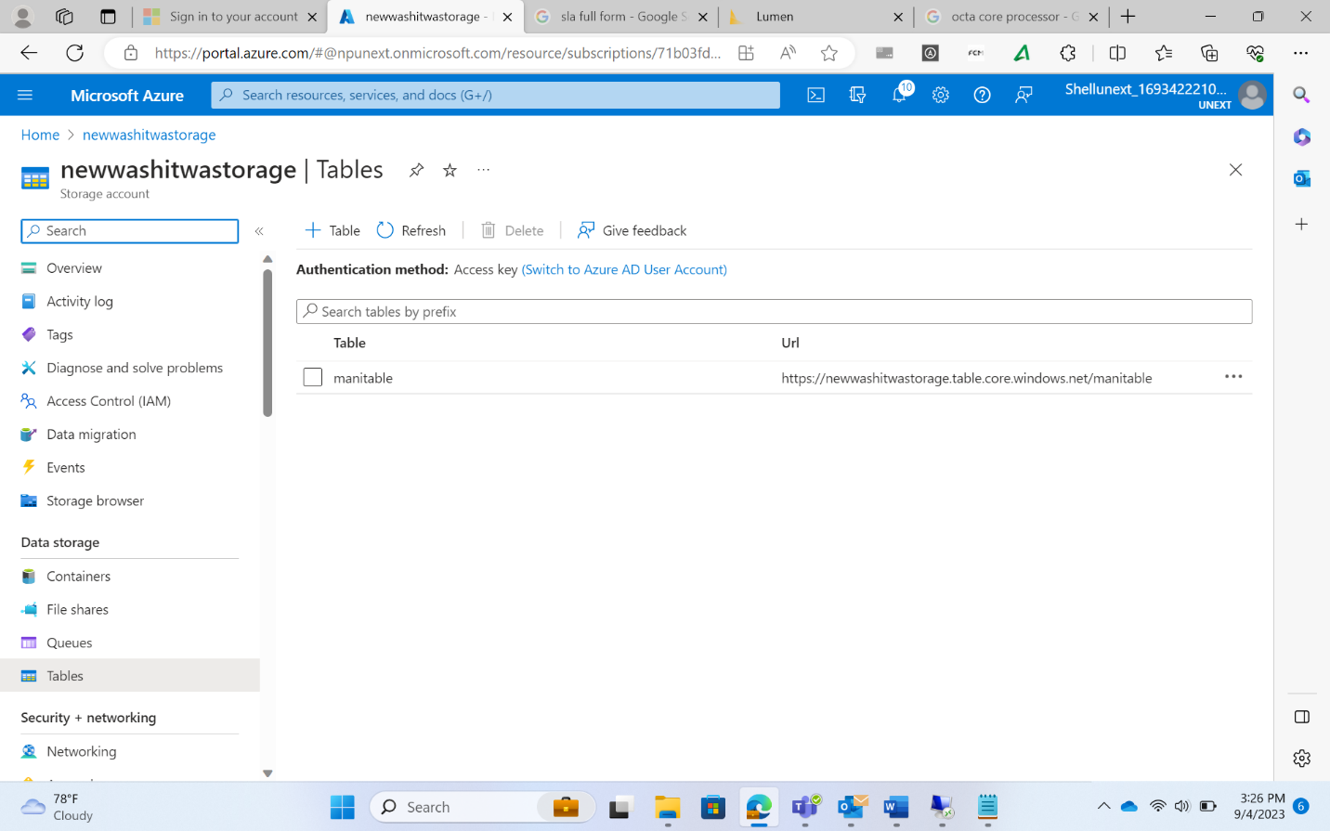

Azure Pricing Calculator

* To check the cost of different services
* Based on the region and other configurations the costs will change

Azure Total Cost of Ownership(TCO)

* Define your workloads
* A report will be generated detailing the billing amount of the Azure Services
* It also generates a report comparing the use of on-premises services and the services provided by Azure

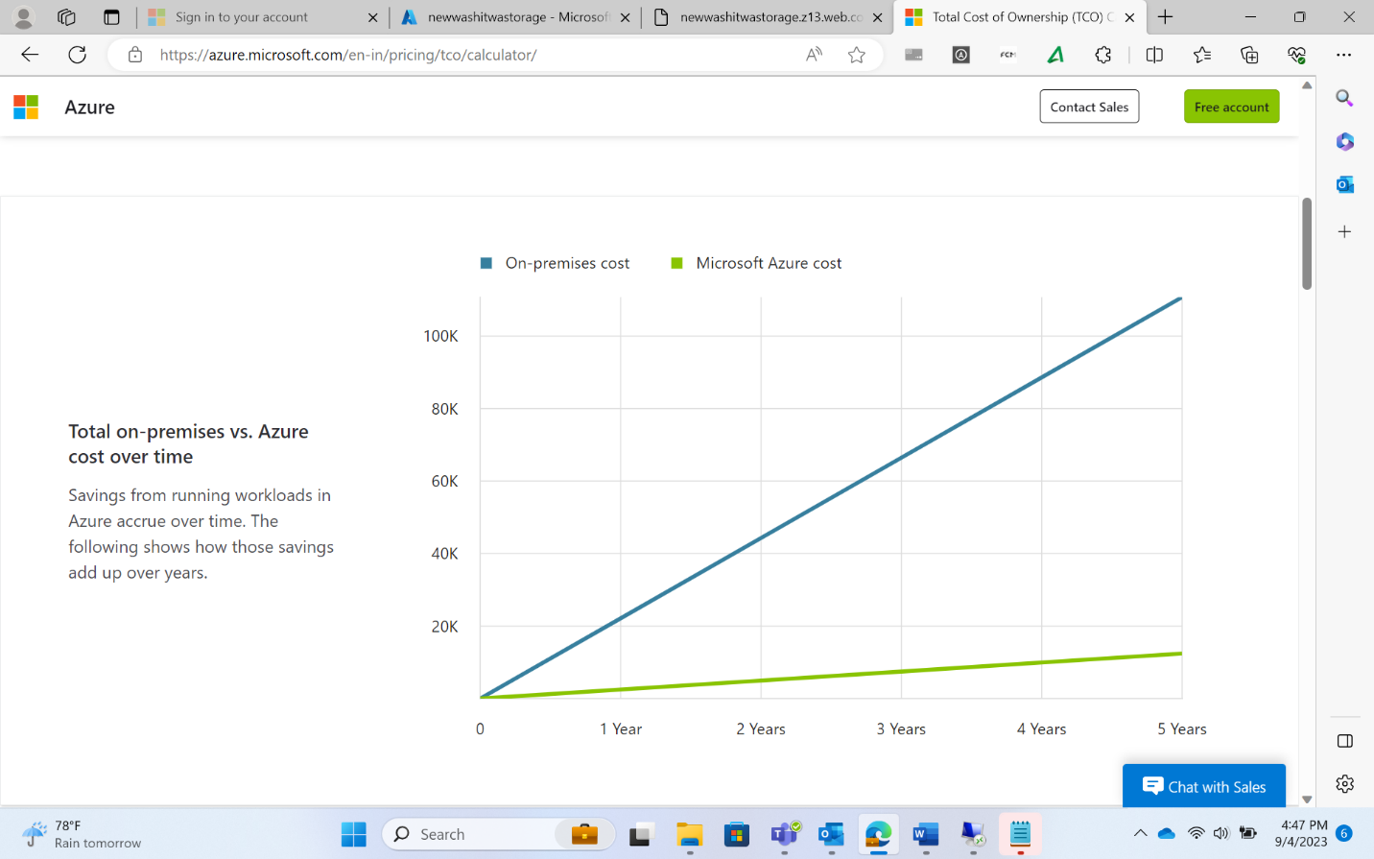

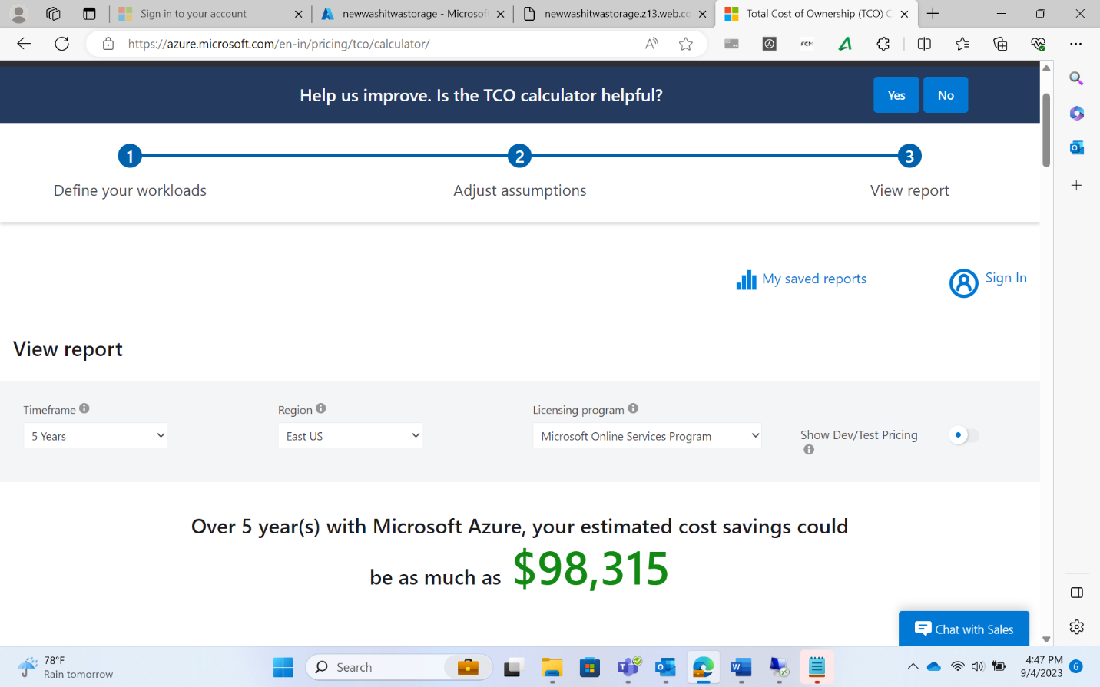

Task

* Check the costs of different services based on different configurations

Static Website

* Create html file
* Index.html
* Go inside storage account
* Inside container
* Static website Disabled to enabled
* Index.html put the file name(index document name)
* Copy primary endpoint
* Paste the copied endpoint in the browser

\*\*\*Note:

* Multiple static web applications can be created but only one can be executed at a time
* This is because there is only one endpoint that corresponds to one static application
* To run multiple web applications, they need to be linked such that running one on the browser causes other applications to run consecutively
* Example:
  + Multiple html files are uploaded in the container
  + Since only one can be run at a time, if the html file that is running calls the other html files in the form of different pages, multiple static applications execution can be achieved

